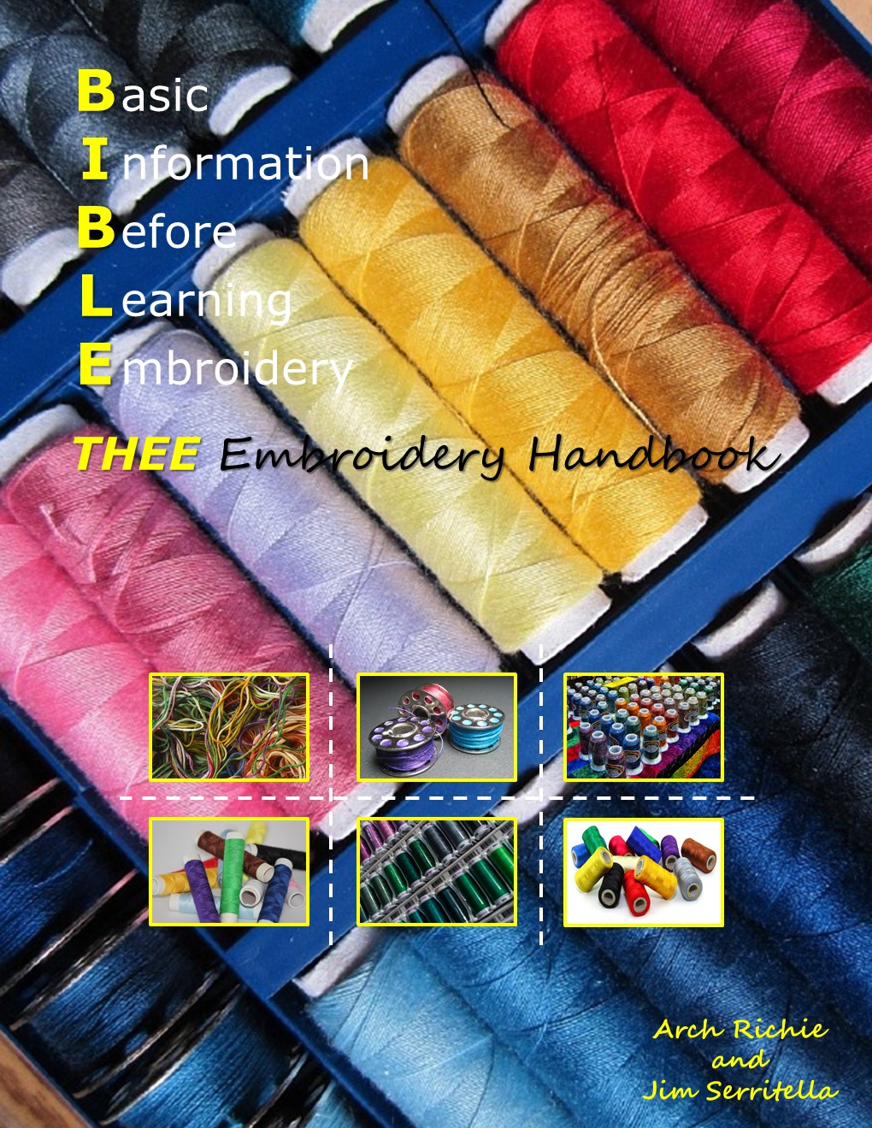
Dedication

We dedicate this book to those individuals who came before us, those who participated in our focus of freedom, and to those who will follow us providing additional efforts to remain free from oppression –
The United States American Veteran – from all services.

The two old dog authors were
US Coast Guard & US Air Force Service men
— Arch Richie and Jim Serritella

Additionally, we would like to dedicate this publication to our wives, Susan and Betty, who’s love of embroidery and service to others brought us to this point in our lives.

Table of Contents
Preface v
A Little History 1
Where to Begin? 2
Questions and Answers 5
What’s it going to cost? $$$$ 5
Can you make money with a single head commercial machine? 5
What do I NEED to be in the embroidery business? 5
A machine 5
Threads 6
Hoops 6
Backing/Topping 6
Designs 6
Some Basic Assumptions 7
What do you need for an embroidery business? Some NON-tangible items… 7
External Marketing Tools 8
What it takes to make money with a single head machine 9
Contract Embroidery … Get Help! 9
Great Customer Service 10
Item/Garment Sales with Embroidery 11
Competitive Pricing (a little high is OK) 11
Time Management 11
TO Digitize…. Or NOT to Digitize? 11
Niches or ??? 12
Pricing…You Need It 12
Taxes 13
Networking…A Must! 13
Time and Money 14
Additional Pricing/Expense Considerations 14
The Reality of Embroidery 15
Room Space 15
Hardware 16
Software 16
Support Equipment 17
Support Services and Organizations 17
Garment/Item Vendors – Trade Shows 18
Design Companies 19
Formats 19
Training 19
Marketing Hints 20
Tricks 21
Soda Straw 21
Thread Racks & Frames 22
Lessons Learned 22
Deposit Comes With The Order 22
Sewout a Proof for a Large Order (More Than 1) 23
Marketing Information 24
INTRODUCTION 24
Two Stories 25
Is It Profitable? 27
Full Cost Analysis? 27
Expensive Toys? 28
Cons 28
What Event Should You Really Go To? 29
What Is Mobile Embroidery? 29
We Embroider Your Material – Here! 29
Tear-Down Set-Up Time 30
Can You Fix It? 30
How Much And What Type Of Apparel Do You Bring? 30
Questions – That Need Answers 31
Travel Distance 33
Be Ready – Just In Case 33
Events? 33
Need Help? 34
Production Control 34
New Trailer Concept 35
Storage 35
Heavy It Up 36
What Does it Take to be a Successful Mobile Embroiderer? 36
More Questions 36
Thoughts And Considerations 37
The Trailer 38
The Layout 40
Outdoor Setup 43
Indoor Setup 50
The Checklist 50
Internal Traveling 51
Traveling Safety 52
In Summary 53
Intellectual Property Release – Permission to Copy a Logo 55
Policy for Sewing on the Customer-Provided Material 56
Sewout Production Approval – Customer Approval Before Sewing Any Order 57
Laundry/Washing Instructions 59
Company Information 60
1.0 INTRODUCTION 60
1.1 Purpose of the Corporation 60
1.2 Beliefs of the Corporation 60
1.3 Corporate Structure 61
2.0 PERSONNEL POLICY 61
2.1 Conditions of Employment 61
2.1.1 Non-Discrimination 61
2.1.2 Disciplinary Policies 62
2.1.3 Conflict of Interest 64
2.1.4 Full Time and Part Time Employees 64
2.1.5 Outside Employment 65
2.1.6 Alcohol and Drugs 65
2.1.7 Dependability 65
2.1.8 Normal Hours 65
2.1.9 Lunch Hours 66
2.1.10 Overtime 66
2.2 Absenteeism 67
2.3 Use of Office 68
2.4 Pay Day Schedule 69
2.5 Payroll Records 69
2.5.1 Change of Employee Status Policy 69
2.5.2 Access to Payroll Information 70
2.6 Performance Evaluations 70
2.7 Vacation, Holiday and Leave Benefits 70
2.7.1 Vacation Plan 70
2.8 Holidays 72
2.8.1 Eligibility 72
2.9 Sick Leave 72
2.9.1 Eligibility 73
2.9.2 Administration 73
2.3 Leave of Absence 73
2.3.1 Military Leave 74
2.3.2 Maternity Leave 74
2.3.3 Jury Duty 75
2.3.4 Bereavement 75
2.4 Inclement Weather 75
2.5 Hospital and Medical Insurance 76
2.6 Life Insurance and Accidental Death or Dismemberment 76
2.7 Disability Insurance 76
2.8 Workman’s Compensation Insurance 77
2.9 Unemployment Compensation 77
2.10 Social Security 77
2.11 Education 77
2.11.1 Tuition Reimbursement 78
2.12 Parking 78
3.0 WORK RULES 78
3.1 Confidentiality of Business Information 78
3.2 Team Work and Task Sharing 79
3.3 Dress and Behavior 79
3.4 Noise 79
3.5 Housekeeping 80
3.6 Utilities 80
3.7 Personal Visitors 80
3.8 Personal Use of Office Equipment 80
3.9 Charity Drives and Contributions 80
3.10 Outside Solicitors 81
3.11 Suggestions 81
3.12 Grievances 81
3.13 Employee Area 82
3.14 Building Emergencies 82
3.15 Security 82
3.16 Community Relations 83
3.17 Bulletin Boards 83
3.18 Flowers and Plants 83
3.19 Authorized Travel 83
3.19.1 Use of Company Vehicle 83
3.19.2 Rental Cars/Vehicles 84
3.19.3 Authorization for Travel 84
3.19.4 Traveling 84
3.19.5 Travel Expense Report 84
3.20 Company Credit Cards 84
3.21 End of Employment 84
3.21.1 Termination 84
3.21.2 Retirement 85
Staff Assessments (Raises) 86
The Bonus 86
Written Performance Review Outline 86
The Outline 87
Employment Agreement 89
Interesting Articles 95
Mistakes Embroiderers Make and Wish They Didn’t 95
Business Plan Outline 99
Buying a Single Head Machine 109
SEW Ya Wanna Buy an Embroidery Machine? 109
Beginners Guide to Profitable Embroidery 117
Glossary of Embroidery Terms 118
Needle & Backing Reference Chart 135
Backing FAQs 137
Backing Types Pros & Cons 138
Toppings: 140
Adjusting The Thread Tension 140
Setting The Upper Thread Tension (Using the a Tension Gauge) 141
Bobbin Reference Guide 142
Thread Tensions FAQ 143
Looping and Birdsnesting 147
Pricing 149
How to Sell Decorated Embroidery 150
The End 186

The End
In the world of embroidery, there is no end…the cone just keeps unwinding. 5,000 meters is about 200,000 inches of thread. It just keeps coming unraveled!!
THEE Embroidery Handbook is a compendium of information you can use to your benefit for the development of your business. The articles are open for you to customize and adopt for your company. The entire handbook is a WORD document, so you can change text, wording, imaging to best suit your situation. All supplied text is a suggestion for your consideration (as in The Company Policy Manual or the wording on the Permission to sew a logo form).
Our suggestion is to put the handbook into a 3-ring binder, and add notes/text to it as you see important articles that have a direct bearing or impact on your embroidery life. New technology is always coming down the road. Embrace it, go with it, and learn from it. You will be a better embroiderer and business person.
Join an organization such as NNEP (www.nnep.org) or a machine users’ group. Get involved and ask questions and provide answers (if you can). Attend conventions and announce yourself ahead of time, meet new friends, face to face. They’re all lovely people to know.
Maybe this section heading should be “THE BEGINNING.” Life has an end, but in the world of embroidery…and contrary to the beginning text…

“In Embroidery-land, there is Utopia!”
Enjoy my friends.

